# Abstract System Architecture

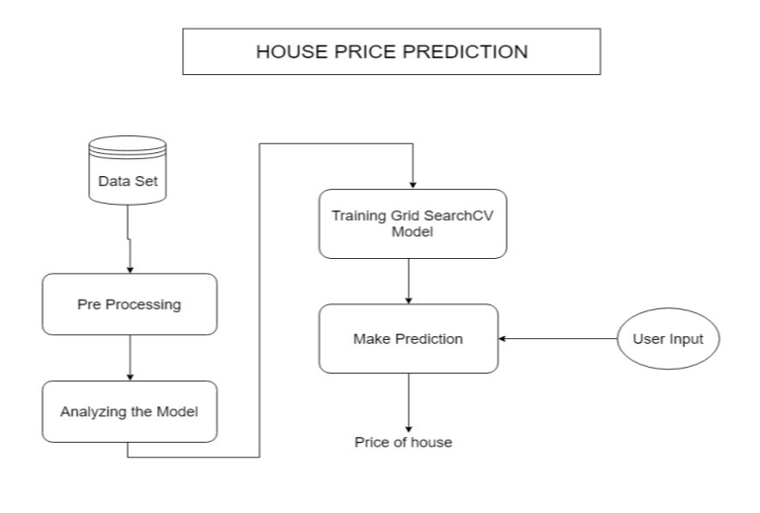

The Purpose of this project is to develop an application to predict the Sale price of the house. Since, due to the demand for Houses in recent times, there are a lot of real estate agents arises and tries to cheat the house holder by lowering there house value and try to sell the house to customer for high price and taking the difference amount as a agents commission. So an application which finds the actual price of a house is really very much useful in the field of Real Estate.

Objectives

* Accurate real estate pricing is one of the key issues for countries all over the world.
* Current market housing prices may cause people to be misled by actions of sellers and other bidders, such as price manipulation and shill bidding.
* As it is unrealistic to achieve both goals to a high degree, they want to find a balance between profit and speed.

Result Analysis Conclusion

* The R-squared Score of our built model is achieved more than 85%
* The accurate value found by value is 0.8567784606316289
* It produces the learning curves for model and Complexity curve for over all model to explore the best parameter.

Regularized regression , which is to fix these issues , will Improve the model by a rather limited level Eventhough these improvements are kind of small, the proposed regularized regression model is still meaningful: it did provide better modeling results.

Major References

1. Yu,JiafuWu.2016.*Real Estate Price Prediction with Regression and Classification,* CS229 Autumn Project Final Report ,Stanford University 2016.

[2] L.Li,K.-H.Chu.*Prediction of real estate price variation based on economic parameters*, International Conference on Applied System Innovation 2017.



House Price Prediction

Naveen Kumar M ( 2015103519 )

Umapathi C ( 2015103613 )

Submitted for CS7711 - Creative & Innovative Project Laboratory (Group 3) Course Instructor: R.Bhuvaneshwari